LAPORAN PRAKTIKUM ALGORITMA DAN STRUKTUR DATA
PRAKTIKUM 3


Dzakiy Ibnu Khoir (5225600061)
PROGRAM STUDI SARJANA TERAPAN TEKNOLOGI GAME
JURUSAN TEKNOLGOI MULTEMDIA KREATIF
POLITEKNIK ELEKTRONIKA NEGERI SURABAYA
2026

Latihan 1
Code
#include <iostream>
using namespace std;

#define MAX 5

class Stack
{
private:
int top;
string data[MAX];

public:
Stack()
{
top = -1;
}

bool isFull()
{
return top == MAX - 1;
}

bool isEmpty()
{
return top == -1;
}

void push(string item)
{
cout << "\nPush -> " << item << endl;

if (isFull())
{
cout << "Inventory penuh!\n";
return;
}

top++;
data[top] = item;

debug();
}

void pop()
{
cout << "\nPop\n";

if (isEmpty())
{
cout << "Inventory kosong!\n";
return;
}

cout << "Item digunakan: " << data[top] << endl;
top--;

debug();
}

void peek()
{
if (isEmpty())
{
cout << "Inventory kosong\n";
return;
}

cout << "Item terakhir: " << data[top] << endl;
}

void display()
{
if (isEmpty())
{
cout << "Inventory kosong\n";
return;
}

cout << "\nIsi Inventory (Top -> Bottom):\n";

for (int i = top; i >= 0; i--)
{
cout << data[i] << endl;
}
}

void debug()
{
cout << "\nVisual Stack (Vertical)\n";
cout << "TOP index = " << top << "\n\n";

for (int i = MAX - 1; i >= 0; i--)
{
cout << "+---------+\n";

if (i == top && !isEmpty())
cout << "| " << data[i] << " | <-- TOP\n";
else if (i <= top)
cout << "| " << data[i] << " |\n";
else
cout << "| |\n";
}

cout << "+---------+\n\n";
}
};

int main()
{
Stack inventory;

inventory.push("Potion");
inventory.push("Sword");
inventory.push("Shield");

inventory.display();

inventory.pop();

inventory.display();

return 0;
}

Visualisasi
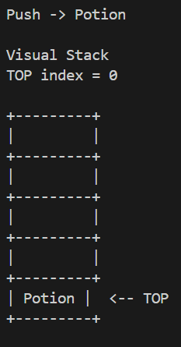

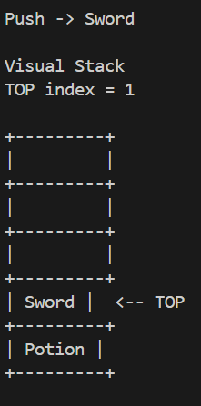

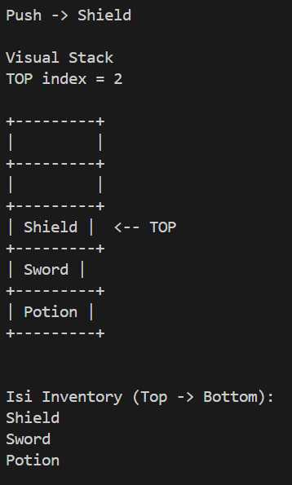

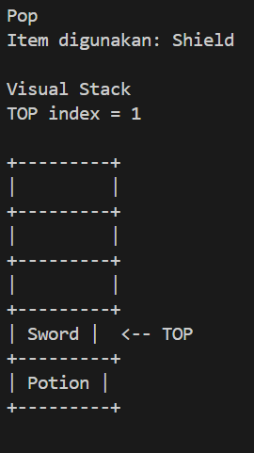

Latihan 2
Code
#include <iostream>
using namespace std;

#define MAX 10

class Stack
{
private:
int top;
string command[MAX];

public:
Stack()
{
top = -1;
}

bool isEmpty()
{
return top == -1;
}

void push(string cmd)
{
cout << "\nPlayer Action -> " << cmd << endl;

if (top == MAX - 1)
{
cout << "Command penuh\n";
return;
}

top++;
command[top] = cmd;

debug();
}

void undo()
{
cout << "\nUNDO COMMAND\n";

if (isEmpty())
{
cout << "Tidak ada command untuk undo\n";
return;
}

cout << "Undo command: " << command[top] << endl;

top--;

debug();
}

void show()
{
if (isEmpty())
{
cout << "History kosong\n";
return;
}

cout << "\nHistory Command (Top -> Bottom)\n";

for (int i = top; i >= 0; i--)
{
cout << command[i] << endl;
}
}

void debug()
{
cout << "\nVisual Command Stack\n";
cout << "TOP index = " << top << "\n\n";

for (int i = MAX - 1; i >= 0; i--)
{
cout << "+----------------+\n";

if (i == top && !isEmpty())
cout << "| " << command[i] << " | <-- TOP\n";
else if (i <= top)
cout << "| " << command[i] << " |\n";
else
cout << "| |\n";
}

cout << "+----------------+\n";
}
};

int main()
{
Stack action;

action.push("Move Forward");
action.push("Jump");
action.push("Shoot");

action.show();

action.undo();

action.show();

return 0;
}

Visualisasi
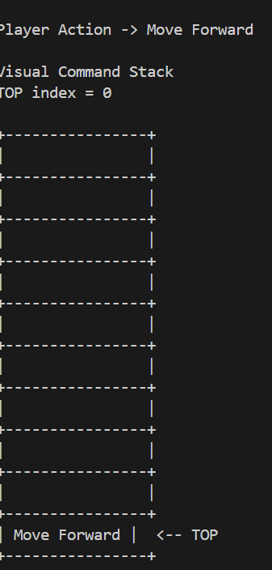

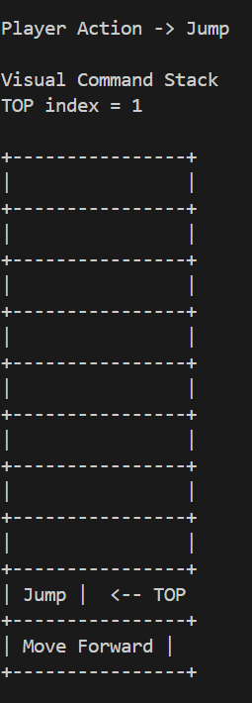

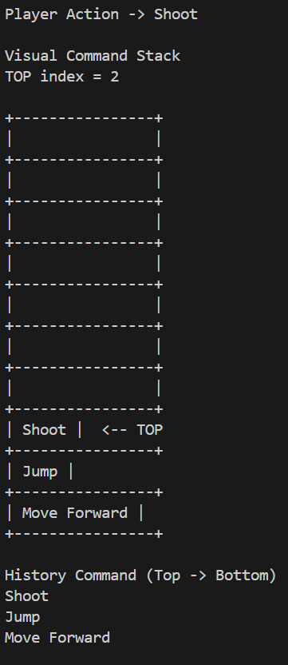

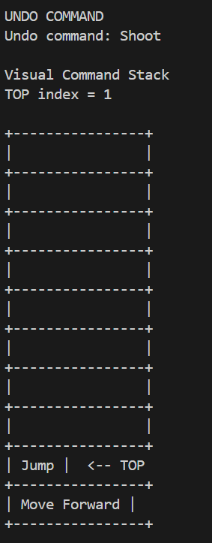

Latihan 3
Code
#include <iostream>
using namespace std;

#define MAX 5

class CircularQueue
{
private:
int front;
int rear;
int data[MAX];

public:
CircularQueue()
{
front = -1;
rear = -1;

for (int i = 0; i < MAX; i++)
data[i] = 0;
}

bool isFull()
{
return (rear + 1) % MAX == front;
}

bool isEmpty()
{
return front == -1;
}

void debug()
{
cout << "\nQueue State\n";
cout << "Front = " << front << endl;
cout << "Rear = " << rear << endl;

cout << "\nIndex : ";
for (int i = 0; i < MAX; i++)
cout << i << " ";

cout << "\nData : ";
for (int i = 0; i < MAX; i++)
cout << data[i] << " ";

cout << "\n";
}

void enqueue(int value)
{
cout << "\nEnqueue -> " << value << endl;

if (isFull())
{
cout << "Queue penuh\n";
return;
}

if (isEmpty())
front = rear = 0;
else
rear = (rear + 1) % MAX;

data[rear] = value;

debug();
}

void dequeue()
{
cout << "\nDequeue\n";

if (isEmpty())
{
cout << "Queue kosong\n";
return;
}

cout << "Data keluar: " << data[front] << endl;

data[front] = 0; // membersihkan slot

if (front == rear)
front = rear = -1;
else
front = (front + 1) % MAX;

debug();
}

void display()
{
if (isEmpty())
{
cout << "Queue kosong\n";
return;
}

int i = front;

cout << "\nIsi Queue:\n";

while (true)
{
cout << data[i] << endl;

if (i == rear)
break;

i = (i + 1) % MAX;
}
}
};

int main()
{
CircularQueue q;

q.enqueue(10);
q.enqueue(20);
q.enqueue(30);

q.display();

q.dequeue();

q.display();
}

Visualisasi
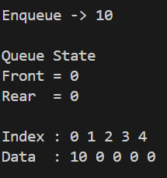
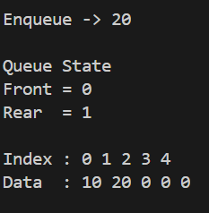
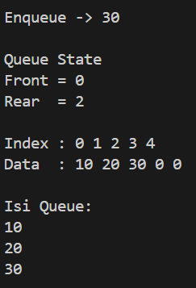
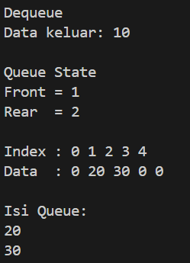

Latihan 4
Code
#include <iostream>
using namespace std;

#define MAX 4

class EnemyQueue
{
public:
int front;
int rear;
string enemy[MAX];

EnemyQueue()
{
front = -1;
rear = -1;
}

bool isEmpty()
{
return front == -1;
}

void display()
{
cout << "\nQueue State\n";
cout << "Front : " << front << endl;
cout << "Rear : " << rear << endl;

cout << "Index : ";
for (int i = 0; i < MAX; i++)
cout << i << " ";

cout << "\nData : ";
for (int i = 0; i < MAX; i++)
{
if (enemy[i] == "")
cout << "- ";
else
cout << enemy[i] << " ";
}

cout << "\n\n";
}

void enqueue(string e)
{
cout << "\nEnqueue -> " << e << endl;

if ((rear + 1) % MAX == front)
{
cout << "Queue penuh\n";
return;
}

if (isEmpty())
front = rear = 0;
else
rear = (rear + 1) % MAX;

enemy[rear] = e;

display();
}

void spawnEnemy()
{
cout << "\nSpawn Enemy\n";

if (isEmpty())
{
cout << "Tidak ada enemy\n";
return;
}

cout << "Enemy Spawn: " << enemy[front] << endl;

front = (front + 1) % MAX;

display();
}
};

int main()
{
EnemyQueue spawn;

spawn.enqueue("Zombie");
spawn.enqueue("Goblin");
spawn.enqueue("Orc");
spawn.enqueue("Skeleton");

spawn.spawnEnemy();
spawn.spawnEnemy();
spawn.spawnEnemy();

spawn.enqueue("Dragon");

spawn.spawnEnemy();
spawn.spawnEnemy();

return 0;
}

Visualisasi
